[1]

A Deaf-to-hearing communication aid on a mobile phone

**Muyowa Mutemwa**, William D. Tucker and Michael Norman

Department of Computer Science, University of the Western Cape, Bellville, South Africa

Telephone: +(27) 21 959-2461, Fax: +(27) 21 959-3006, Email: {**2550606**, btucker, mnorman}@uwc.ac.za

**Abstract**—**This paper seeks to discusses work in progress to implement a preliminary mock-up of a Deaf-to-hearing communication aid on a mobile phone. The goal is to ease communication between a Deaf and hearing users with interpreted communication between sign language and English on a mobile platform. The mock-up is meant to help a Deaf person convey medical conditions to a doctor face-to-face in the office. The user interface has pre-recorded sign language videos for the Deaf user, and English text for the doctor. This paper introduces the background of the project and briefly discusses related technology. Results from a preliminary trial of the PC-based mock-up with actual Deaf users are reported and discussed. Finally mapped out is a way to implement the communication aid system on a mobile device in a context free manner, allowing the plug and play of more communication scenarios.**

Index Terms—sign language interface, mobile communication aid, Deaf users, medical consultation

# INTRODUCTION

T

HIS paper describes a communication aid on a mobile phone that helps Deaf[2] users who only use South African sign language (SASL) to communicate with a hearing doctor that cannot sign. A PC-based mock-up was designed and tested out with Deaf users. The mock-up employs a guided set of web pages with a combination of SASL videos and English text to enable a Deaf person to tell a doctor how s/he is feeling. At each step, the Deaf user responds to a question presented in SASL, finally enabling the system to convey how the Deaf user is feeling into simple English for a doctor to understand. The mock-up is called SignSupport and was built by an industrial design engineering student from the Netherlands. We conducted an evaluation of the SignSupport mock-up at the Bastion of the Deaf in Newlands, a building where a non-governmental organization (NGO) called Deaf Community of Cape Town (DCCT) is based. DCCT members help trial the system [1].

This paper describes the next step in SignSupport's evolution to prototype the mock-up on a mobile phone. The actual implementation of SignSupport requires a mobile phone with a data connection and a browser that supports Adobe Flash video (FLV). The intention is to run the system within a mobile browser instead of using a third party media player, to ease both system development and enhance the user experience. To support in site interaction video streaming is also necessary .

Section gives some background on DCCT, and briefly describes related mobile technologies. Section III details the protocol of the user test of the SignSupport mock-up conducted at the Bastion and discusses the results from that test. Section gives our proposed design of SignSupport on a mobile device. Section concludes the paper with a roadmap of future work.

# Background and Related Technology

A series of Deaf telephony projects have been conducted with DCCT members at the Bastion over the years . As a result Deaf people there have become accustomed to using information and communication technologies (ICT) at a small 'internet cafe'. Most Internet usage at the Bastion involves visual media, e.g. to watch videos of Deaf people dancing, educational programmes in sign language, and Deaf channels on Youtube . Our results indicate that Deaf users prefer to use SASL to communicate. They can also use text but their text skills are limited due to under-education. DCCT members tend to own low-end mobile phones with low-resolution cameras and narrow bandwidth data connectivity. The findings have also indicated that Deaf users do not take advantage of low cost text messaging like MXit. They might be more inclined to use data services if content were available in SASL on a mobile phone.

Advanced mobile phones support video calling, but the poor resolution and low frame rate of the video remains unacceptable for SASL communication. Voice transport in the video calling is still prioritised which is pointless for sign language communication. Using data access, a YouTube client is available for a limited number of phones and mobile operating systems. Most video playbacks of on mobile devices come in the form of third party media players, e.g. Real Player. Many vendor browsers, including cross-platform browsers like Opera Mini still struggle to render FLV video playback, yet this goal remains significant to obtain generalised access to sites like YouTube on a mobile phone. Currently, a cross platform browser called Skyfire (www.skyfire.com) enables a user to view almost any web page that can be viewed with a desktop browser, including those with Java scripts and Adobe Flash content, such as videos on YouTube . Flash Lite 3 enables sophisticated mobile experiences for users with the support of web content and video streaming with FLV. FLV supports H.264 video codecs. Multi-platform application programmatic interfaces (APIs) are available for smart phone developers, and Flash Lite support, which has recently been included in the latest Nokia phone browsers. FLV files can be embedded into a Wireless Application Protocol (WAP) page though other more technical features, such as third-party enhancements to view various rich content types, e.g. Real Media Player on the Symbian 60 series phones, is required to view FLV files .

# Preliminary user trial and results

Since mobile FLV support is still in its infancy, we tested a mock-up of a SASL-based mobile communication aid for Deaf users in a browser on a PC . This section describes the protocol used to test the prototype with Deaf users at the Bastion. The intention is use the same protocol to test out the next prototype built for a mobile phone emulator and ultimately on an actual mobile phone.

We selected four Deaf participants and scheduled a time for the testing. The participants were paired to allow discussion (in SASL) between them during the trial. A SASL interpreter facilitated communication between the Deaf participants and the researchers (one of whom participated from the Netherlands via Skype). The session was also recorded with a digital video camera for subsequent analysis.

Participants were briefed about the prototype and what was required of them regarding the trial, via the SASL interpreter. Only one pair was allowed to be in the room during the evaluation. They provided them with a storyboard of a scenario were the participants had pneumonia and they were asked to consult a doctor that they otherwise would not be able to communicate with. SignSupport on the PC guided them through a series of SASL videos asking them questions about their condition. During the test, they were encouraged to ask questions and/or discuss issues amongst themselves. After interacting with SignSupport, they were shown how the doctor would respond to their input. A discussion/informal interview was conducted with the focus group after running the trial with each of the two participant pairs. These methods helped the participants express themselves on how they felt about the prototype.

Overall, the users indicated that they would like to see the prototype developed further. At first, neither pair appeared to understand how the prototype worked. However, as the trial went on, they came to understand the interaction techniques. Observing them helped us identify user interface challenges. For example, one unappreciated feature was the change in screen background colour to distinguish between questions and answers. The participants complained that some of the sign language video questions were not clear. The participants also preferred clickable images instead of text to provide answers to questions. One participant also mentioned that a touch screen would help.

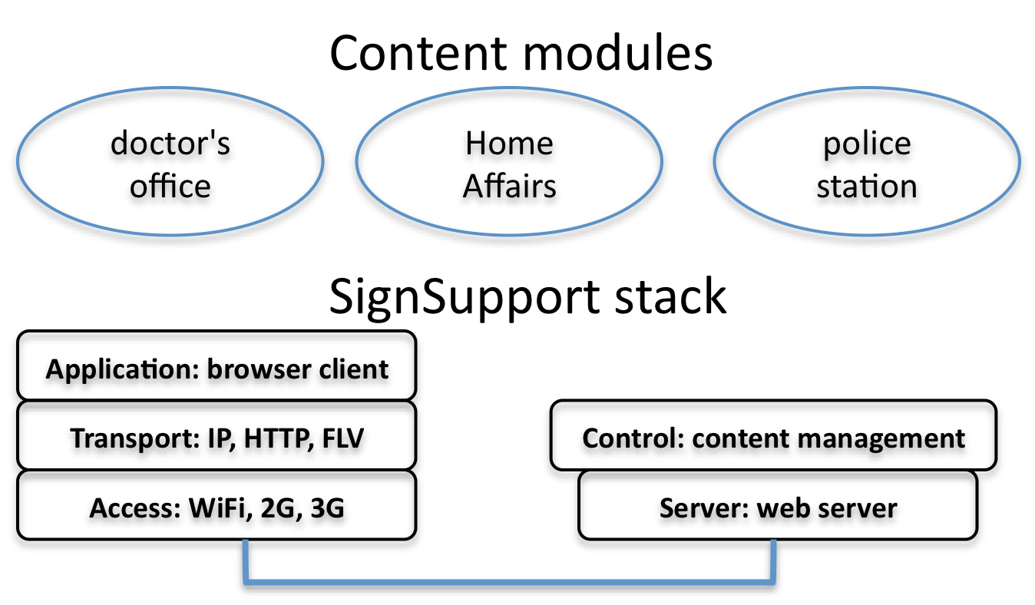

Figure : SignSupport will also be designed to accommodate multiple content modules. The SignSupport layered system design contains an access layer to accommodate multiple wireless protocols, e.g. WiFi, 2G and 3G; a transport layer to transfer HTTP and FLV over Internet Protocol (IP); an application layer for the mobile phone-based browser; a server layer for a web server; and a layer for content management

# Mobile prototype design

Based on encouraging results from the preliminary trial, the next version of SignSupport will use some of the technologies identified in Section , e.g. Skyfire. Our intention is to design the next prototype with 'plug and play' scenarios, of which the doctor's visit is just one scenario (see ). We would like to experiment with content stored on and off the device to understand the full range of performance and cost issues. The next user trial will be performed at the Bastion with the same four Deaf participants following the same protocol described in Section on either a mobile phone emulator or a physical phone if possible.

# Conclusion and Future Work

The initial SignSupport mock-up on a PC shows a potential to help Deaf users use a mobile device to communicate with people that do not sign. The next version of SignSupport will run in a mobile browser and allow multiple content modules. We will continue to conduct user trials with Deaf participants to provide a solution that is useful for them.

# References

1. Looijesteijn K (2009). The design of a Deaf-to-hearing communication aid for South Africa, Unpublished MSc thesis, Delft University of Technology, Netherlands.
2. Krikke J (2004). Streaming video transforms the media industry, *IEEE Computer Graphics and Applications*, 24(4), 6-12.
3. Glaser M and Tucker WD (2004). Telecommunications bridging between Deaf and hearing users in South Africa, *Proc. Conference and Workshop on Assistive Technologies for Vision and Hearing Impairment, (CVHI 2004)*, Granada, Spain, (CD-ROM publication).
4. Ma ZY and Tucker WD (2008). Adapting x264 to asynchronous video telephony for the Deaf. *Proc. South African Telecommunications Networks and Applications Conference,* (*SATNAC 2008*), Wild Coast Sun, Eastern Cape, South Africa, 127-132.
5. Wagner ED (2008). Realizing the promises of mobile learning, *Journal of Computing in Higher Education*, 20(2), 4-14.
6. Potter AB, McIntyre N and Middleton CA (2008). How Usable Are Outdoor Wireless Networks? *Canadian Journal of Communication*, 33(3).
7. Koller A, Foster G and Wright M (2008). Java Micro Edition and Adobe Flash Lite for arcade-style mobile phone game development: a comparative study. *Proc. annual research conference of the South African Institute of Computer Scientists and Information Technologists (SAICSIT 2008)*, 131-138.

**Muyowa Mutemwa** is currently studying for a Masters degree at UWC with the Bridging Applications and Networks Group (BANG).

William D. Tucker is a senior lecturer in computer science at UWC and leads BANG research there.

Michael Norman is a senior lecturer in computer science at UWC and his main interest is software engineering.

1.
2. Deaf with a capital 'D' is different from deaf or hard of hearing in that Deaf people primarily use sign language to communicate and define their sense of culture, as opposed to the other groups that use spoken, and consequently textual, languages like English or Xhosa..